Multitasking molecule repairs damaged nerve cells, scientists discover in ‘stunning’ research breakthrough
JANUARY 8, 2015 / ANNE HOLDEN
Every molecule in the body has a job to do—everything from maintaining healthy cell functions to removing dead or decaying cells requires a coordinated series of molecular switches to complete. There’s a lot we know about what these molecules do, but even more that we are still discovering.
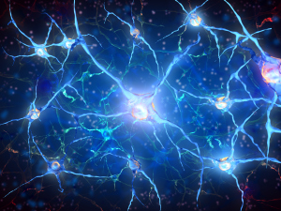
The PSR-1 molecule, which normally clears out dead or dying nerve cells, has also been observed trying to repair them.
And as reported in a pair of studies published this week in Nature and Nature Communications, a molecule that has long been known to clear out dying or damaged nerve cells also—amazingly—tries to heal them.
The molecule at the heart of these studies is called phophatidylserine receptor, or PSR-1 for short. PSR-1’s main job had been to target and remove cells that were dead or dying—a sort of cellular ‘cleanup crew.’
Some cells die because they’ve reached the end of their life cycle and are scheduled for destruction, a programmed cell death known as apoptosis. Other cells die because they have been damaged by disease or injury. In this study, scientists at the University of Colorado, Boulder and the University of Queensland (UQ) in Brisbane, Australia, discovered that not only does PSR-1 clear out dead cells, it tries to save the ones that haven’t quite kicked the bucket.
Specifically, the team observed PSR-1 literally reconnecting nerve fibers, known as axons, which had broken due to injury.
“I would call this an unexpected and somewhat stunning finding,” said one of the study’s lead authors Ding Xue in a news release. “This is the first time a molecule involved in apoptosis has been found to have the ability to repair severed axons, and we believe it has great therapeutic potential.”
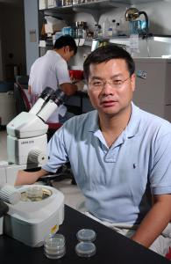
Professor Ding Xue of the University of Colorado Boulder. [Credit: Casey A. Cass, University of Colorado]
Injuries to nerve cells that reside in the brain or spinal cord are particularly distressing because once damaged, the cells can’t be repaired. As a result, many research groups have looked to innovative ways of coaxing the cells to repair themselves. Xue and Hilliard see the potential of PSR-1 to be involved in such a strategy.
“This will open new avenues to try and exploit this knowledge in other systems closer to human physiology and hopefully move toward solving injuries,” said Hilliard.
The discovery of PSR-1’s role in axon repair is based off a key difference between cells undergoing programmed cell death and those that are dying due to injury.
During apoptosis, cells release a beacon to alert PSR-1 that they’re ready for removal. But when a nerve cell is injured, it sends out a distress signal. Explained Xue:
“The moment there is a cut to the nerve cell we see…a signal to PSR-1 molecules in the other part of the nerve that essentially says ‘I am in danger, come and save me.’”
While these experiments were performed in the model organism C. elegans (a small worm often used in this sort of research), the researchers are optimistic that a similar process is taking place in human nerve cells.

